|  |
| --- |
| COM109 |
| CV Showcase Web Page |
| Six Key Design Features and their Implementation |

|  |
| --- |
| B00756824, Nathan Curran, Computer Science  4-15-2019 |

## Image Map Landing Page

The image map serves as the landing page for this project and therefore it was essential for it to be structured with a clear, easy to follow architecture. I decided to use the rotate function in CSS for the span elements and arrange them using CSS again to create an appealing layout. The span elements are styled to blend with the rest of the headings until the mouse is hovered over them. At this point they change colour indicating that they are a link.

#### Example of rotate function in CSS

1. #cvrequest {
2. */*position and rotate the text*/*
3. **position**: fixed;
4. **top**: 270px;
5. **-moz-transform: rotate(90deg);**
6. -webkit-transform: rotate(90deg);
7. -o-transform: rotate(90deg);
8. -ms-transform: rotate(90deg);
9. transform: rotate(90deg);
10. **font-size: 42pt;**
11. **text-align**: **left**;
12. **left**: 730px;
13. **line-height**: 1;
14. }

#### Example of link hover function in CSS

1. a {
2. */*change the link appearance to fit in with the other text*/*
3. **text-decoration: none;**
4. **display**: contents;
5. **color**: white;
6. }
8. **a:hover {**
9. */*link changes colour on hover*/*
10. **color**: mediumblue;
11. }

#### HTML code

1. <**div** id="COM109">
2. <**h2**>COM109</**h2**>
3. </**div**>*<!--closes the COM109 div-->*
4. **<div id="IWA">**
5. <**h3**>Interactive<**br**>Web<**br**>Authoring</**h3**>
6. </**div**>*<!--closes the IWA div-->*
7. <**div** id="myname">
8. <**h1**>NATHAN<**br**>CURRAN</**h1**>
9. **</div>*<!--closes the myname div-->***
10. <**div** id="cvrequest">
11. <**span**><**a** href="http://scm.ulster.ac.uk/~b00756824/workspace/com109/assignment_2/web_form.html">Request CV</**a**></**span**>
12. </**div**>*<!--closes the cvrequest div-->*
13. <**div** id="keyfeatures">
14. **<span><a href="http://scm.ulster.ac.uk/~b00756824/workspace/com109/assignment_2/key_features.pdf">Key Features</a></span>**
15. </**div**>*<!--closes the keyfeatures div-->*
16. <**div** id="allelements">
17. <**span**><**a** href="https://scm.ulster.ac.uk/~b00756824/workspace/com109/allElements2.html">All Elements</**a**></**span**>
18. </**div**>*<!--closes the allelements div-->*
19. **<div id="myinterests">**
20. <**span**><**a** href="https://scm.ulster.ac.uk/~b00756824/workspace/com109/my_interests2.html">My Interests</**a**></**span**>
21. </**div**>*<!--closes the myinterests div-->*

#### Evidence of Image Map

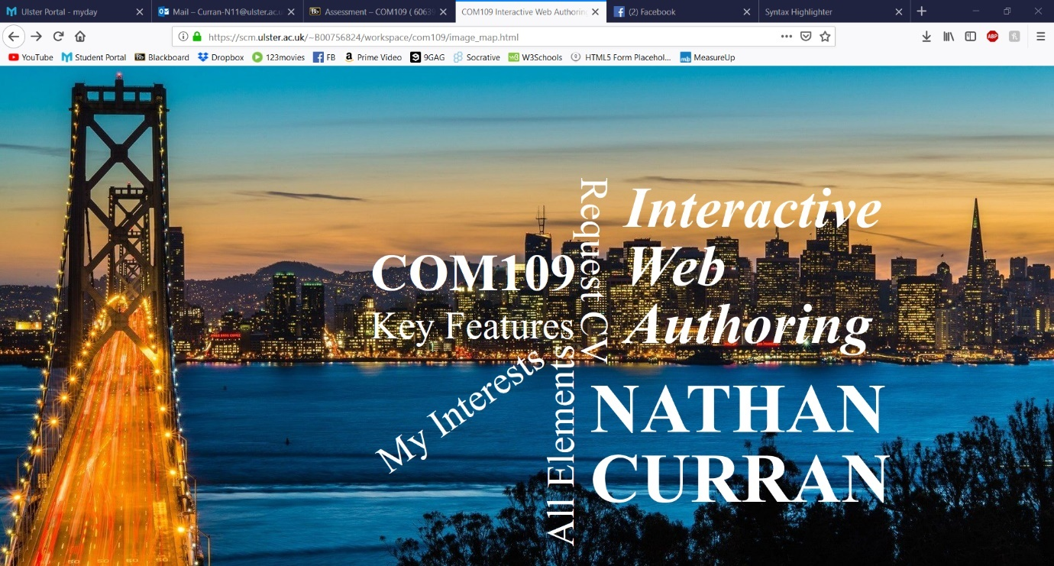

#### Evidence of Image Map on hover

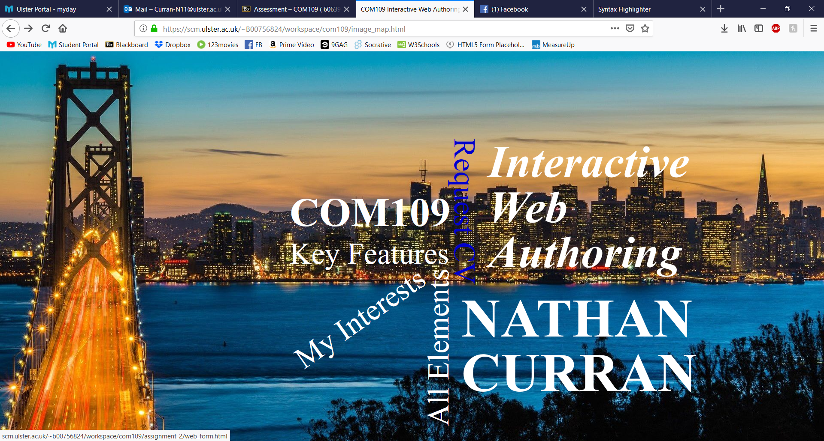

## CV Request Web Form with Validation

The CV request form, next to the image map is the most important feature of this project. It is designed to look professional and familiar to modern day users. The form is easy to understand with easy to follow labels for inputs. The form is also validated using jQuery for the firstname, lastname and email input fields. If they are empty or contain invalid data when the submit button is clicked, an alert will appear highlighting the issue and the submit function cannot run until the errors are corrected.

#### Example of the webform CSS

1. header {
2. */*set the banner image*/*
3. **background-image**: url(../images/form_banner.jpg);
4. **background-repeat**: no-repeat;
6. */*center and fit the image*/*
7. */*multi-browser compatability*/*
8. **background-position**: center;
9. -webkit-background-**size**: cover;
10. **-moz-background-size: cover;**
11. -o-background-**size**: cover;
12. background-**size**: cover;
14. */*round the top corners of the header*/*
15. **border-top-left-radius: 5px;**
16. **border-top-right-radius**: 5px;
17. }
18. #container {
19. ***/*resize the container to fit in the middle of the page*/***
20. **background-color**: dimgrey;
21. **padding-top**: 20px;
22. **padding-right**: 20px;
23. **padding-bottom**: 150px;
24. **padding-left: 20px;**
25. **margin-left**: 15%;
26. **margin-right**: 15%;
27. **font-family**: Arial;
28. }
30. #content {
31. */*set a background colour and round the bottom corners*/*
32. **border-bottom-left-radius**: 5px;
33. **border-bottom-right-radius**: 5px;
34. **background-color: whitesmoke;**
35. **padding**: 20px;
36. }

#### HTML code

1. <**form** id ="myForm" action="process_CV_request.php" target="_blank" method="post">
2. First name:
3. **<input type="text" id="first_name" name="first_name" placeholder="Your first name..." autofocus><br>**
4. Last name:
5. <**input** type="text" id="last_name" name="last_name" placeholder="Your last name..." ><**br**>
6. Business name:
7. <**input** type="text" name="business_name" placeholder="Your business name..." ><**br**>
8. **E-mail:**
9. <**input** type="email" id="email_address" name="email_address" placeholder="Your email address..." ><**br**>
10. Type of CV:
11. <**input** type="radio" name="cv_type" value="Long" checked="checked"> Long
12. <**input** type="radio" name="cv_type" value="Short"> Short<**br**><**br**>
13. **Reason for request:**
14. <**textarea** id="comment" name="user_comment" placeholder="Reason for CV request..." style="height:200px" maxlength=200></**textarea**>
15. <**br**>
16. <**input** id="submit" type="submit" value="Submit">
17. </**form**>
18. **<div id="tablelink">**
19. <**a** href="http://scm.ulster.ac.uk/~b00756824/workspace/com109/assignment_2/view_requests_table.php">Who else has viewed this webpage?</**a**>
20. </**div**> *<!--closes the tablelink div-->*

#### jQuery script within the HTML file

1. **<script> //calls the jQuery validation function whenever the form is submitted**
2. $(document).ready(function() {
3. validation();
4. });
5. </**script**>*<!--closes the jQuery script-->*

#### jQuery Validation Function

1. **function** validation() {
2. $( "#myForm" ).submit(**function**( event ) {
3. **var** first_name = $("#first_name").val();
4. **var** last_name = $("#last_name").val();
5. **var email_address = $("#email_address").val();**
7. **var** name_regex = */^[a-zA-Z@_-]+$/*;
8. **var** email_regex = */^([a-zA-Z0-9_\.\-\+])+\@(([a-zA-Z0-9_\.\-\+])+\.)+([a-zA-Z0-9]{2,4})+$/*;
10. **if (first_name == "" || !name_regex.test(first_name)) {**
11. alert("Please enter a valid first name.");

#### Evidence of web form

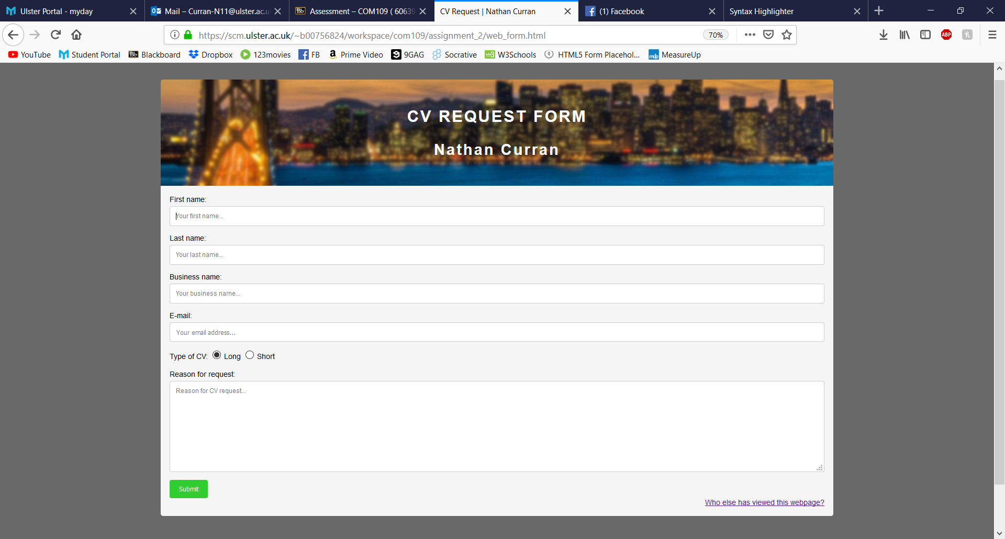

#### Evidence of web form submit with invalid input

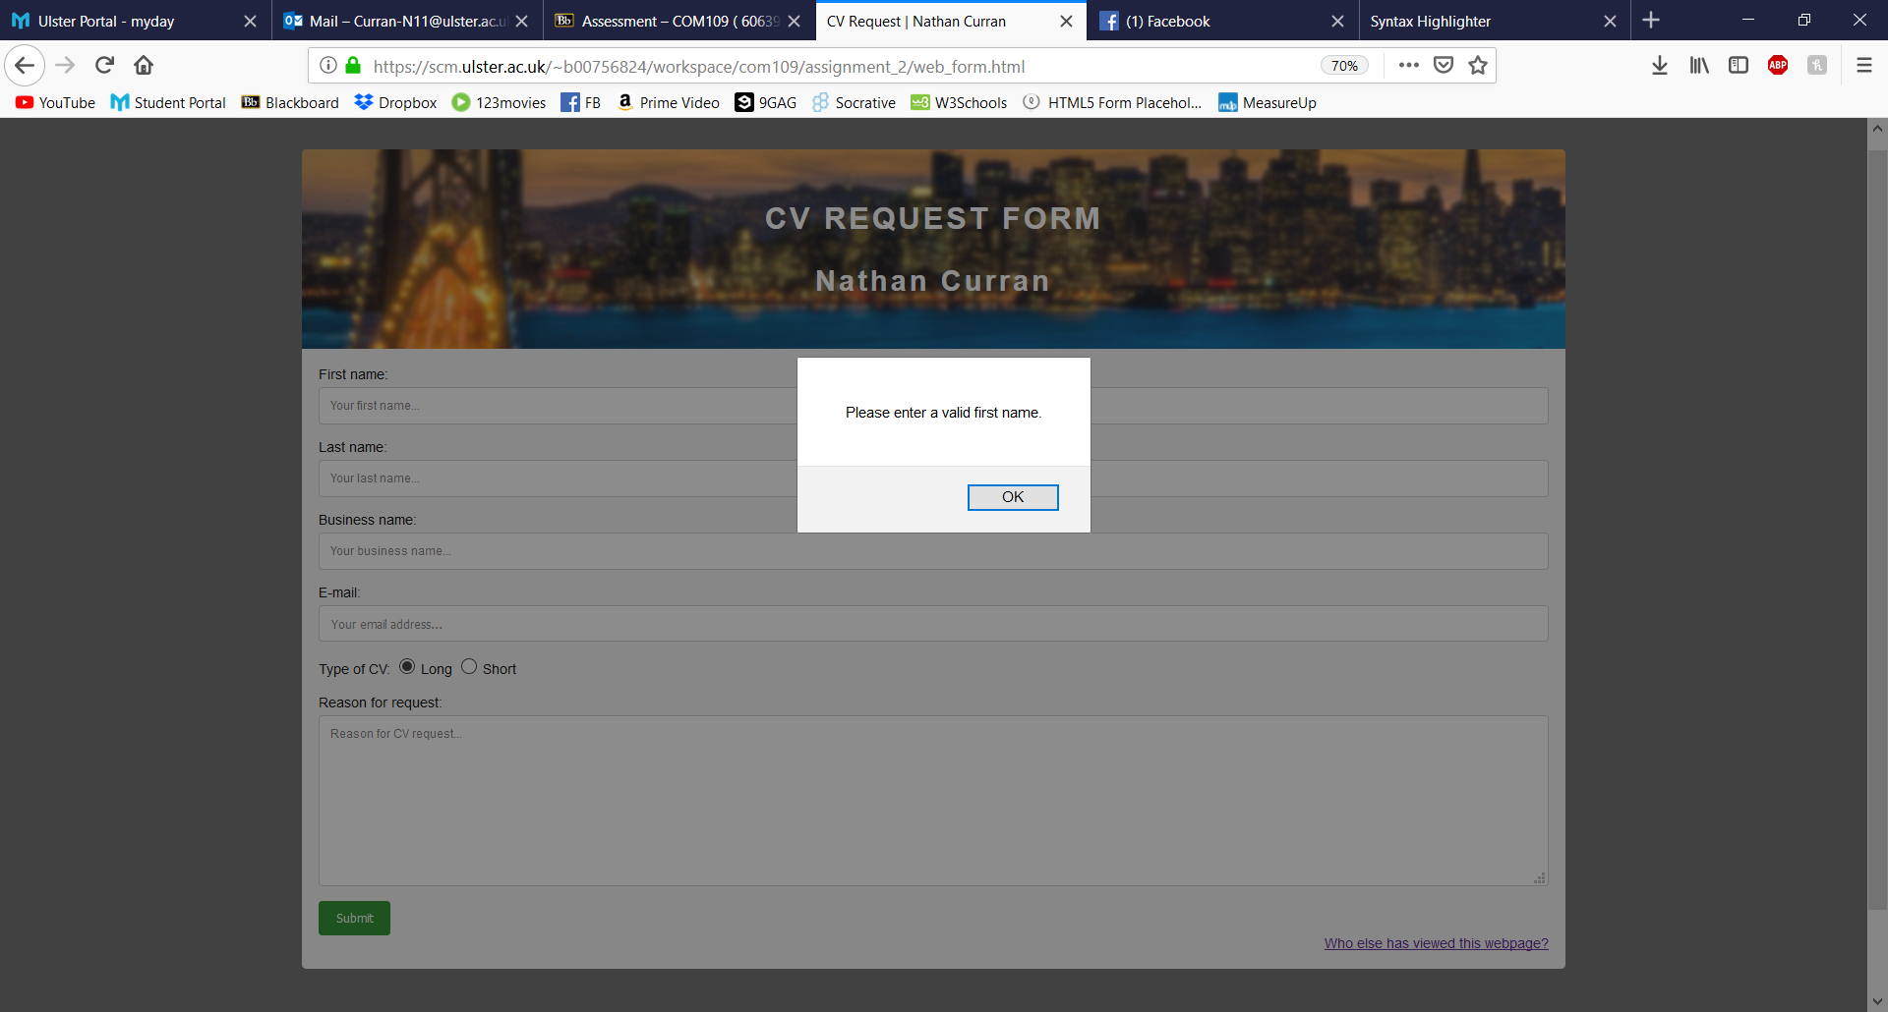

## Confirmation Page with a Link to The Requested CV

The confirmation page appears when the web form is submitted with no errors, it displays a simple message showing the company name and the comment left. A link is also provided to open/download the requested type of CV. The CSS for this page is simple as its purpose is solely to give the user the CV. Therefore, the CSS is very similar to the view_requests_table.css file. This action is carried out using PHP and html.

#### Example of PHP and HTML code

1. <?php
2. if($_SERVER["REQUEST_METHOD"] == "POST"){
3. **$qry = "insert into cv_requests(first_name, last_name, business_name, email_address, cv_type, user_comment)**
4. values('$first_name', '$last_name', '$business_name', '$email_address', '$cv_type', '$user_comment');";
5. $res = $db_connection->query($qry);
6. if ($res)
7. {
8. **echo "<p>Thank you for requesting to see my CV.</p>";**
9. echo "<**p**>Your Company name: <**strong**>".$business_name."</**strong**></**p**>";
10. echo "<**p**>Your comment: ".$user_comment."</**p**>";
11. echo "<**p**><**a** href='files/";
12. if ($cv_type === 'Short')
13. **echo "Short_CV";**
14. else
15. echo "Long_CV";
16. echo".pdf' target='_blank'>View my ".$cv_type." CV</**a**></**p**>";
17. exit();
18. **}**
19. else
20. {
21. echo "<**p**>ERROR.</**p**>";
22. }
23. **}**
24. $db_connection->close();
25. ?>

#### Evidence of a valid form submit

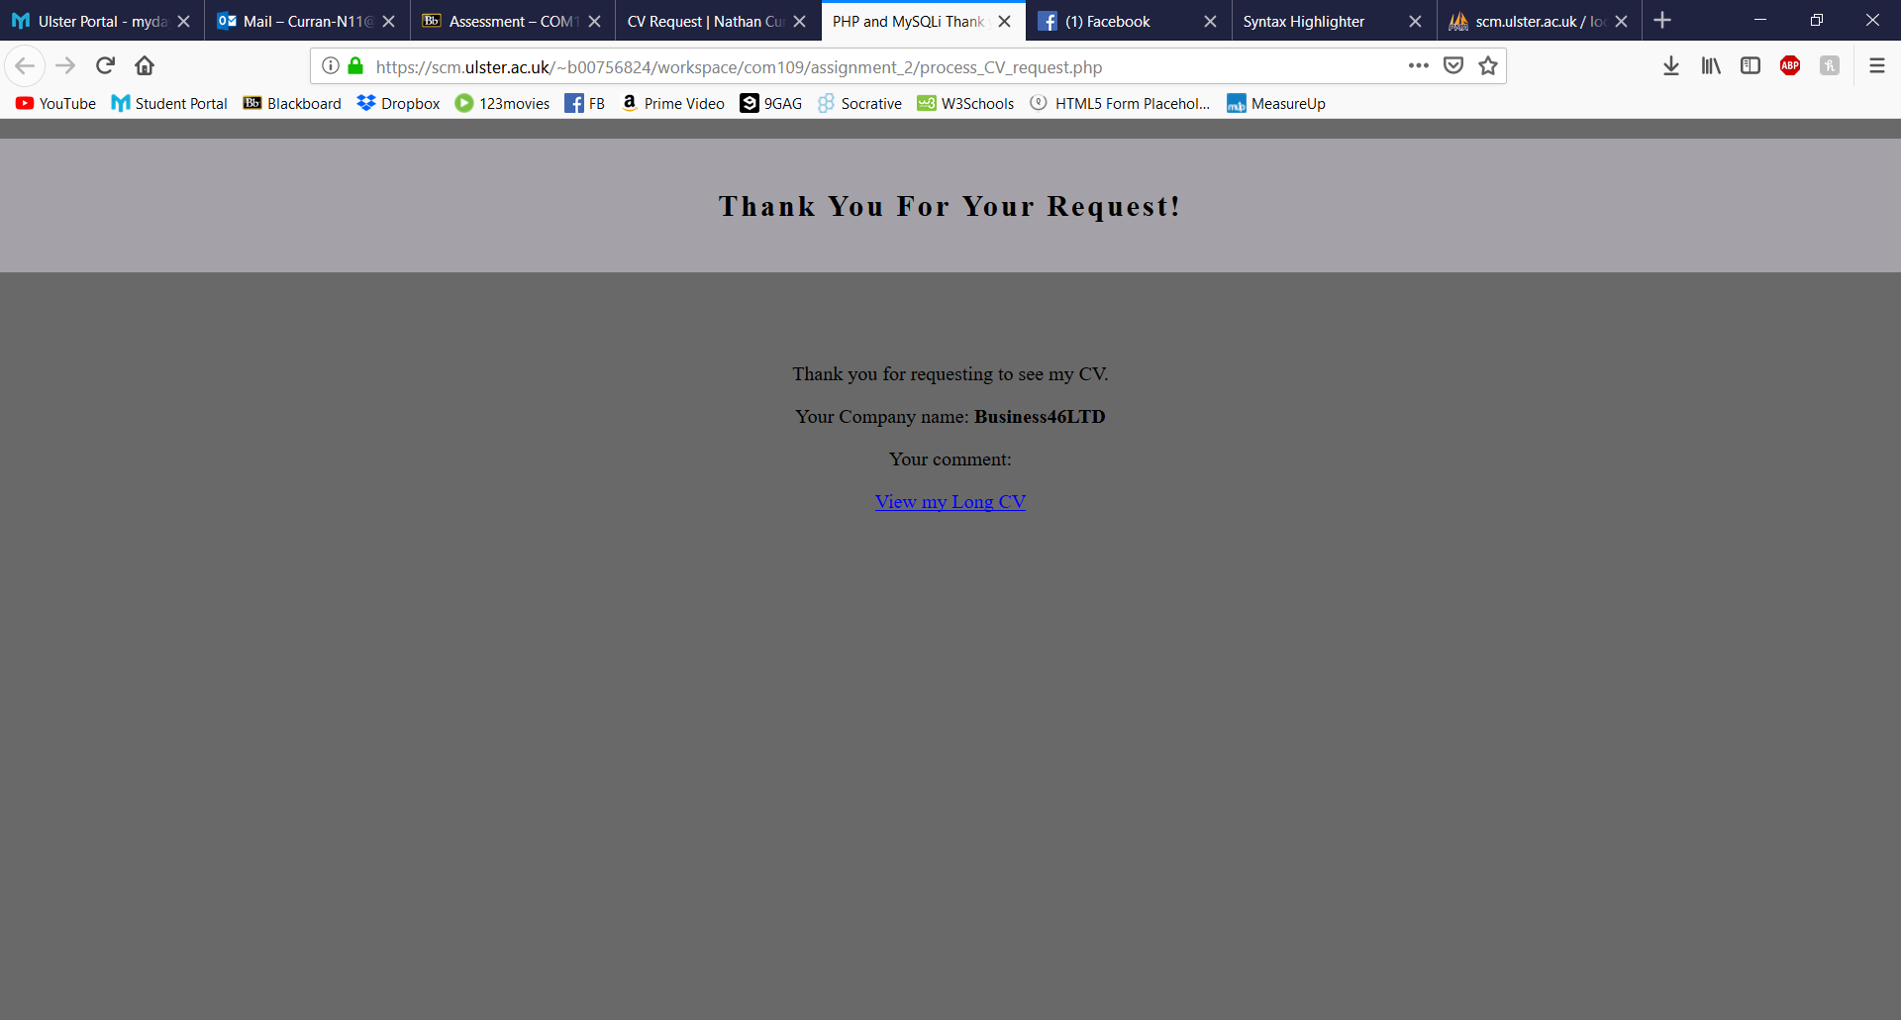

#### Evidence of Retrieving a Long CV

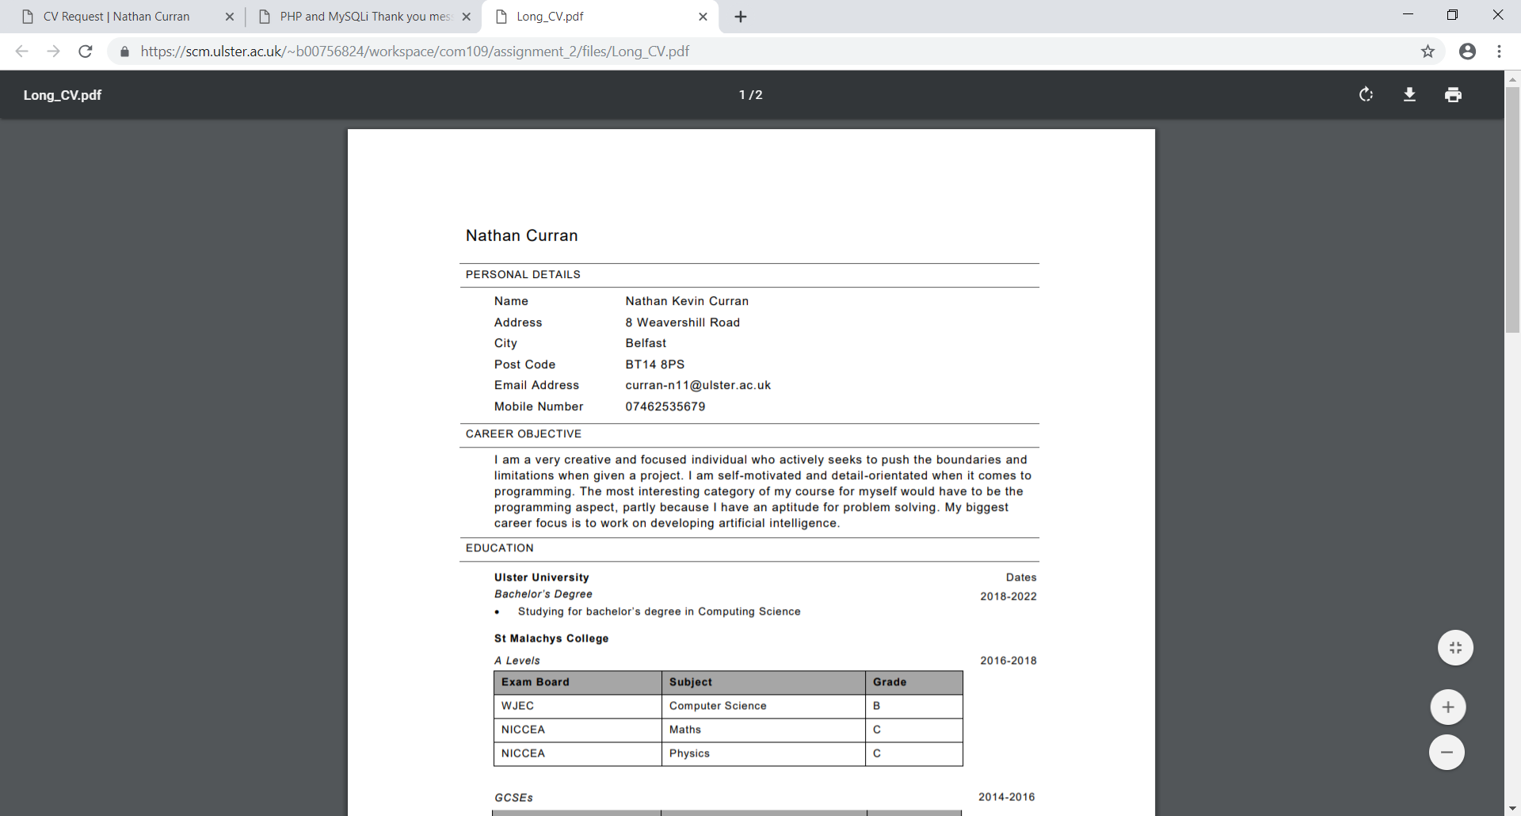

#### Evidence of Retrieving a Short CV

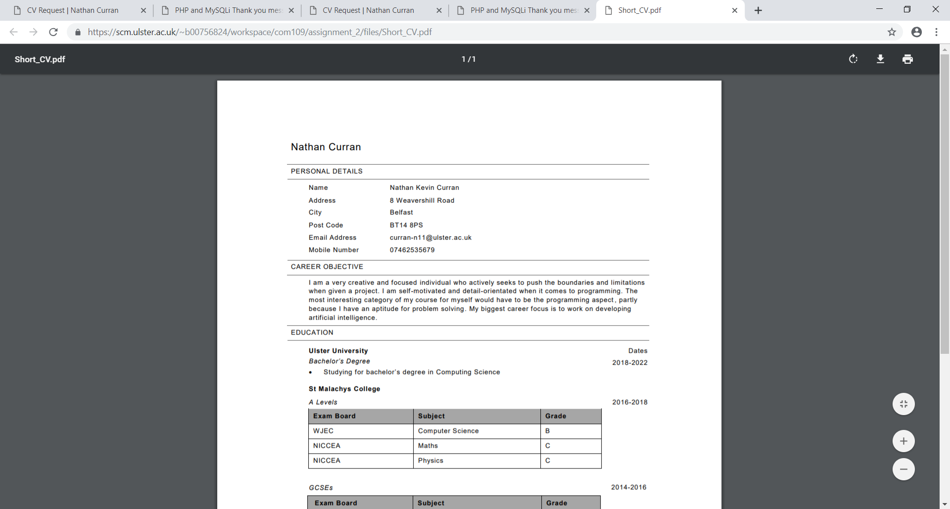

## Summary Table of all The Companies Who Have Requested a CV

The summary table is an important feature for the backend developer (in this case, myself) as it provides a clean and simplified version of the overall table containing the web form information that has been submitted. Currently the only way to access this webpage is through a link at the bottom right-hand corner of the web form, making it accessible to anyone on the web form page. However, since this whole project can only be accessed with my credentials, it is safe to the public for now. If the website was to go public, this link could be removed and access to this page could be located elsewhere with password protection.

#### Evidence of Link to the Summary Table page

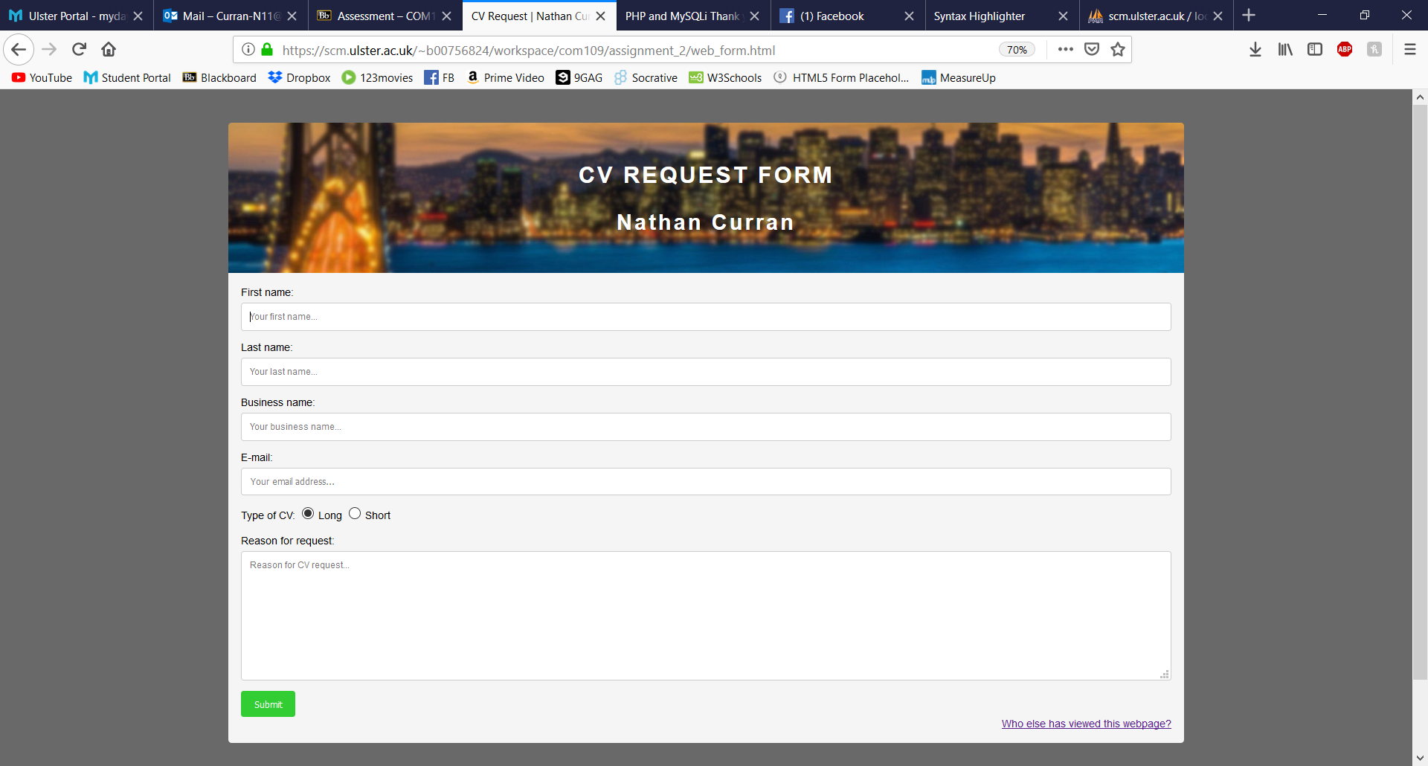

#### HTML Code For Link

1. **<div id="tablelink">**
2. <**a** href="http://scm.ulster.ac.uk/~b00756824/workspace/com109/assignment_2/view_requests_table.php">Who else has viewed this webpage?</**a**>
3. </**div**> *<!--closes the tablelink div-->*

#### Evidence of Summary Table Page

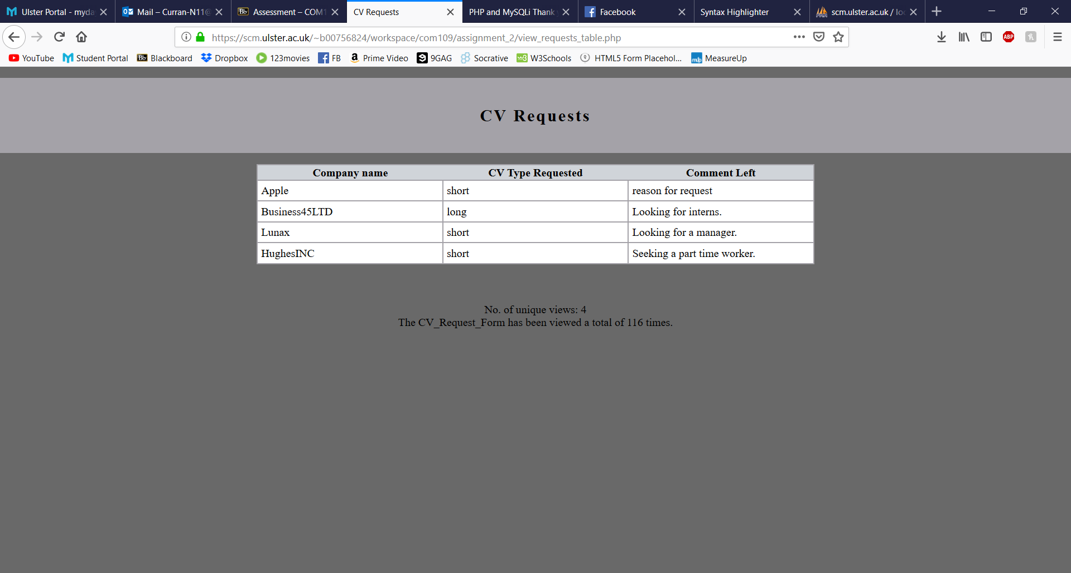

#### Example of HTML and PHP Code

1. <**header**>
2. <**h1**>CV Requests</**h1**>
3. **</header>**
4. <**table**>
5. <**thead**>
6. <**tr**>
7. <**th**>Company name</**th**>
8. **<th>CV Type Requested</th>**
9. <**th**>Comment Left</**th**>
10. </**tr**>
11. </**thead**>
12. <?php
13. **//fetch data from database**
14. if($result->num_rows > 0){
15. while($row = $result->fetch_assoc()){
16. ?>
17. <**tbody**>
18. **<tr>**
19. <**td**><?php echo htmlspecialchars($row['business_name']); ?></**td**>
20. <**td**><?php echo htmlspecialchars($row['cv_type']); ?></**td**>
21. <**td**><?php echo htmlspecialchars($row['user_comment']); ?></**td**>
22. </**tr**>
23. **<?php**
24. }
25. }
26. else
27. {
28. **?>**
29. <**tr**>
30. <**th** colspan="3">The table is empty.</**th**>
31. </**tr**>
32. <?php
33. **}**
34. ?>
36. </**tbody**>
37. </**table**>

#### Example of CSS Code

1. table {
2. */*position the table*/*
3. **margin: 0 auto;**
4. **table-layout**: fixed;
5. **width**:800px;
6. **position**:center;
8. ***/*style the table*/***
9. **background-color**: #FFFFFF;
10. **border-collapse**: collapse;
11. **border-width**: 2px;
12. **border-color**: #A4A2A8;
13. **border-style: solid;**
14. **color**: #000000;
15. }
17. th {
18. ***/*set a heading colour*/***
19. **background-color**: #D0D4D9;
20. }
22. td, tr{
23. ***/*style the cells within the table*/***
24. **border-width**: 2px;
25. **border-color**: #A4A2A8;
26. **border-style**: solid;
27. **padding**: 5px;
28. **}**

## Total and Unique View Counter

Another important feature contained in the Summary Table page are statistics for the total number of views that the web form has gotten and the total number of unique views. This was done using PHP and mySQLi. Again, this will only be available to the backend developer and not the user. The total number of views updates the a table called ‘viewcounter’ each time it is loaded. The number of unique views either updates an existing record or inserts a new record using the IP of the user in a table called ‘unique_visitors’.

#### PHP for the Total Number of Views

This snippet of code lies within the web_form.html file and updates the table.

1. *//connection for database*
2. require_once 'db.php';
4. *//get the total number of page views*
5. **mysqli_query($db_connection, "UPDATE viewcounter SET views = views + 1 WHERE pagename = 'CV_Request_Form';");**

This snippet of code lies within the view_requests_table.php file and displays the total amount of views as well as the total number of unique views.

1. <div id="views">
2. <p><bold>No. of unique views: **<?php** print $numOfRows['total']**?>**<br>
3. The **<?php** print $pagename; **?>** has been viewed a total of **<?php** print $views; **?>** times.</bold></p>
4. </div>

#### PHP for the Total Number of Unique Views

This snippet of code lies within the web_form.html file and updates the table accordingly.

1. $date = date("Y-m-d"); *//set todays date*
2. $userIP = $_SERVER['REMOTE_ADDR']; *//get the current user ip*
4. $query = "SELECT * FROM unique_visitors"; *//select all records query*
5. **$queryresult = $db_connection->query($query);**
6. settype($sqlRowCount, "integer"); *//create a new integer variable*
8. *//if-else statement to get the number of rows in the table*
9. if (is_object($queryresult)){
10. **$sqlRowCount = $queryresult->num_rows;**
11. }
12. else{
13. $sqlRowCount = 0;
14. }
16. *//if-else statement occurs when there are existing records in the table*
17. if($sqlRowCount != 0){
18. *//for loop runs through each row of the table*
19. for($i=0;$i<=$sqlRowCount;$i++){
20. **$row = $queryresult->fetch_assoc();**
21. *//if-else statements occurs if the existing ip of the current record matches the current user's ip*
22. if(preg_match('/'.$userIP.'/i',$row['ip'])){
23. *//the table is updated adding 1 to the view count for the existing record*
24. $updateQuery = "UPDATE unique_visitors SET views=views+1 WHERE ip='**$userIP**'";
25. **mysqli_query($db_connection, $updateQuery);**
26. }
27. else{
28. *//create a new record with the current user's ip*
29. $insertQuery = "INSERT INTO unique_visitors (date, ip) VALUES('**$date**','**$userIP**')";
30. **mysqli_query($db_connection, $insertQuery);**
31. }
32. }
34. }
35. **else {**
36. *//create a new record if there are no existing records*
37. $insertQuery = "INSERT INTO unique_visitors (date, ip) VALUES('**$date**','**$userIP**')";
38. mysqli_query($db_connection, $insertQuery);
39. }

## Mobile and Multi-Browser Compatibility

Finally, yet another important feature of any website is for it to be compatible across multiple browsers and devices.

#### Example of CSS for Multi-Browser Compatibility

1. #cvrequest {
2. */*position and rotate the text*/*
3. **position**: fixed;
4. **top**: 270px;
5. **-moz-transform: rotate(90deg);**
6. -webkit-transform: rotate(90deg);
7. -o-transform: rotate(90deg);
8. -ms-transform: rotate(90deg);
9. transform: rotate(90deg);
10. **font-size: 42pt;**
11. **text-align**: **left**;
12. **left**: 730px;
13. **line-height**: 1;
14. }

#### Example of CSS for Mobile Compatibility

1. */*phone screen conditions*/*
3. @media only **screen** and (**max-width**: 600px){
4. **html,body {**
5. */*format the text*/*
6. **font-size**: 42.5%;
7. **font-weight**: 100;
8. **text-align**: **left**;
9. **color: white;**
10. }

#### Evidence of Multi-Browser Compatibility

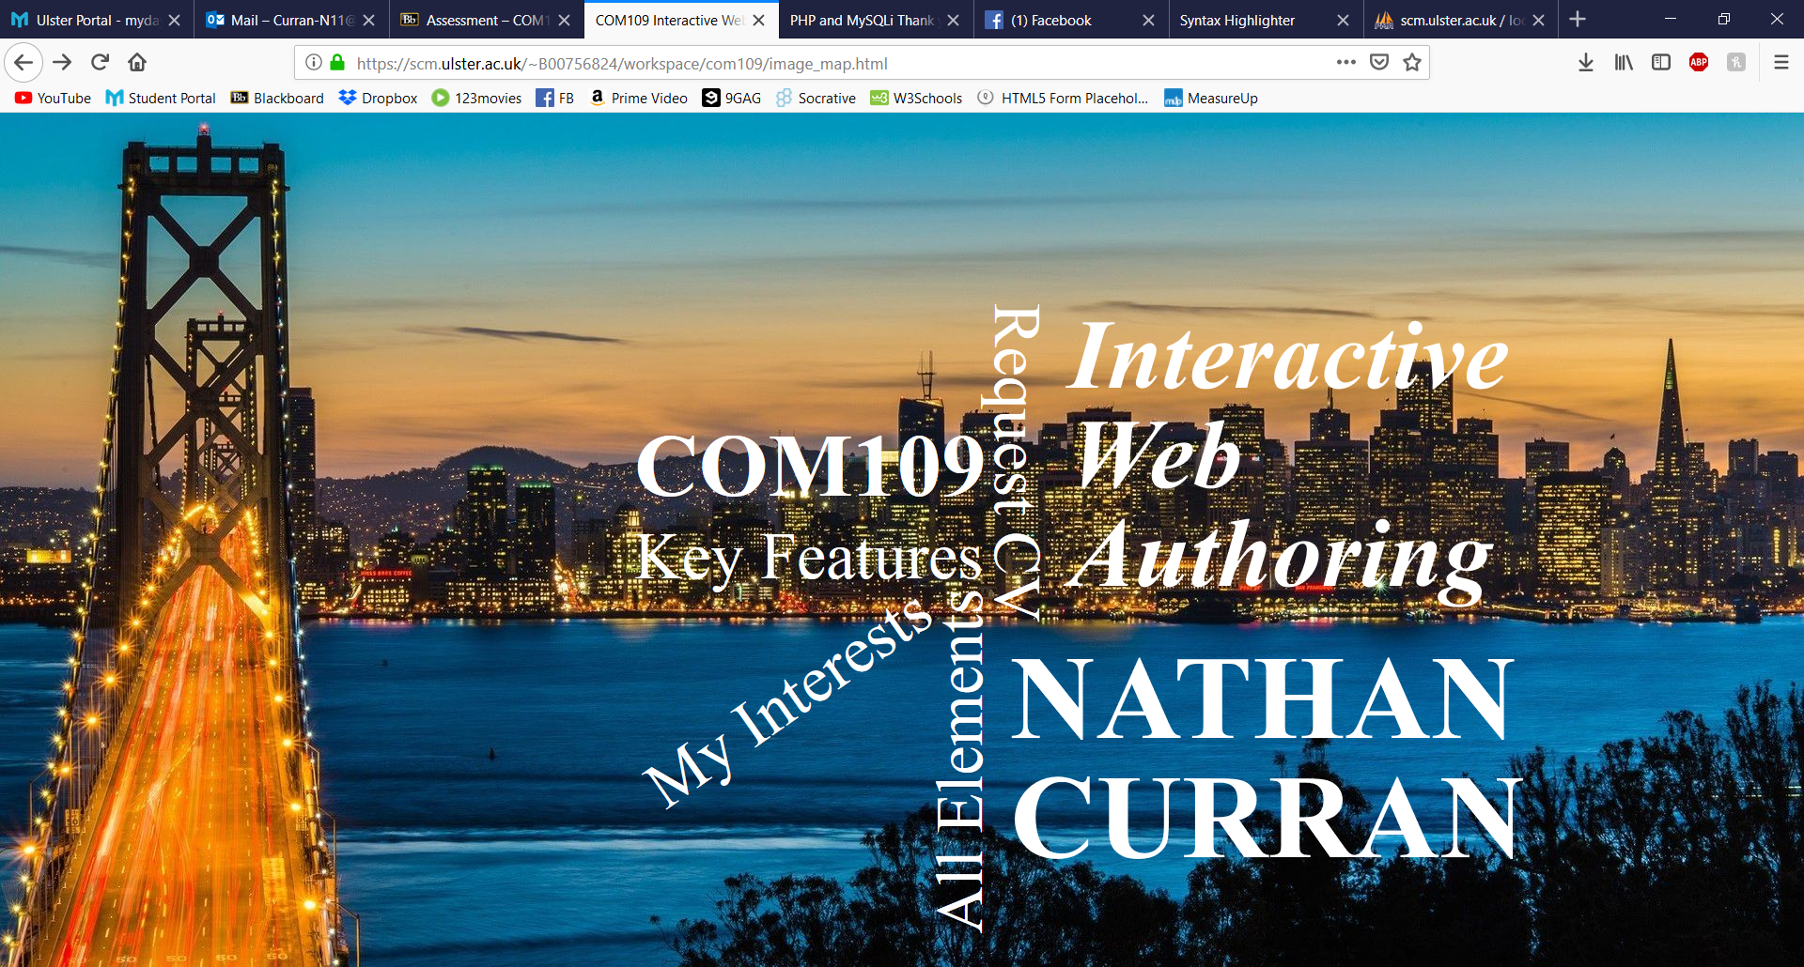





#### Evidence of Mobile Compatibility

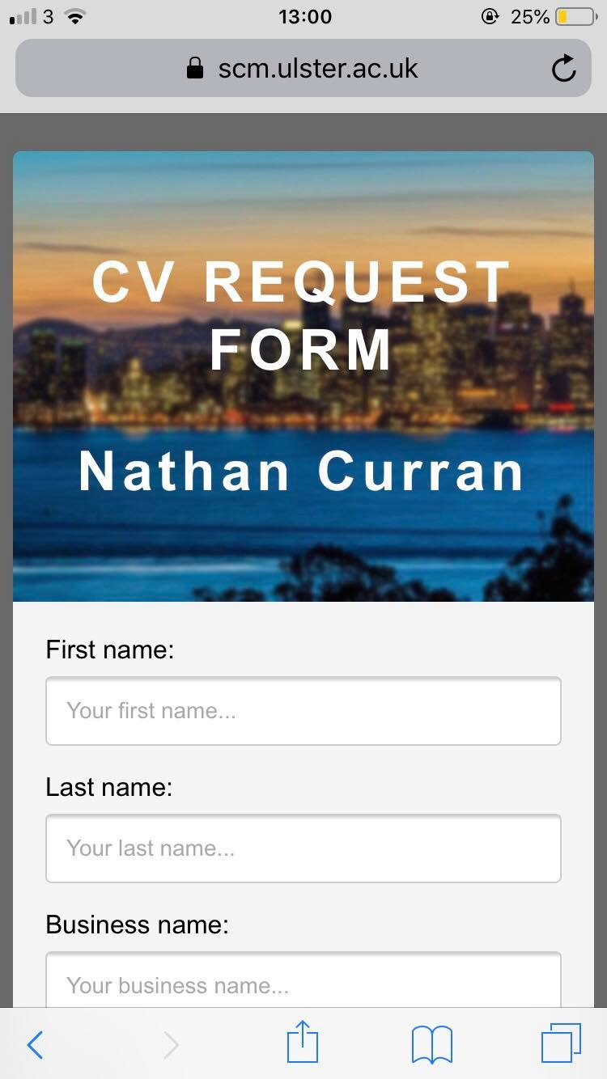

## References

* *W3CSchools jQuery Wiki. Available from:* <https://www.w3schools.com/jquery/default.asp> [Accessed 01 April 2019]
* *W3CSchools PHP Wiki. Available from:* <https://www.w3schools.com/php/default.asp> [Accessed 04 April 2019]
* *W3CSchools CSS Wiki. Available from:* <https://www.w3schools.com/css/default.asp> [Accessed 14 March 2019]
* TheMindSpeaks (2016) *Unique Visitor Counter | PHP & MySQL – TheMindSpeaks. Available from:* [*https://www.youtube.com/watch?v=nI2vexZ06aE*](https://www.youtube.com/watch?v=nI2vexZ06aE) *[Accessed 10 April 2019]*
* *P. Nicholl (2019) COM109 Learning Materials [Accessed March/April 2019]*

## HTML

### Image_map.html

1. <!DOCTYPE html>
2. <**html** lang="en">
3. <**head**>
4. *<!--Determines the default stylesheet for computer and phone screen-->*
5. **<link rel="stylesheet" type="text/css" href="css/image_map.css" media="screen,projector" />**
6. *<!--Sets the size of the elements in the webpage to fit to the appropriate screen size-->*
7. <**meta** name="viewport" content="width=device-width" , inital-scale="1.0" />
8. <**meta** http-equiv="content-type" content="text/html; charset=utf-8" />
9. <**title**>COM109 Interactive Web Authoring | Image Map | Nathan Curran</**title**>
11. <**meta** charset="utf-8" />
12. <**meta** name="Author" content="Nathan Curran" />
13. <**meta** name="Description" content="Image map for COM109" />
14. <**meta** name="Keywords" content="Image Map, Nathan Curran, Undergraduate, Northern Ireland, UK, Education, Higher Education" />
15. **</head>**
16. <**body**>
17. <**div** id="COM109">
18. <**h2**>COM109</**h2**>
19. </**div**>*<!--closes the COM109 div-->*
20. **<div id="IWA">**
21. <**h3**>Interactive<**br**>Web<**br**>Authoring</**h3**>
22. </**div**>*<!--closes the IWA div-->*
23. <**div** id="myname">
24. <**h1**>NATHAN<**br**>CURRAN</**h1**>
25. **</div>*<!--closes the myname div-->***
26. <**div** id="cvrequest">
27. <**span**><**a** href="http://scm.ulster.ac.uk/~b00756824/workspace/com109/assignment_2/web_form.html">Request CV</**a**></**span**>
28. </**div**>*<!--closes the cvrequest div-->*
29. <**div** id="keyfeatures">
30. **<span><a href="http://scm.ulster.ac.uk/~b00756824/workspace/com109/assignment_2/key_features.pdf">Key Features</a></span>**
31. </**div**>*<!--closes the keyfeatures div-->*
32. <**div** id="allelements">
33. <**span**><**a** href="https://scm.ulster.ac.uk/~b00756824/workspace/com109/allElements2.html">All Elements</**a**></**span**>
34. </**div**>*<!--closes the allelements div-->*
35. **<div id="myinterests">**
36. <**span**><**a** href="https://scm.ulster.ac.uk/~b00756824/workspace/com109/my_interests2.html">My Interests</**a**></**span**>
37. </**div**>*<!--closes the myinterests div-->*
38. </**body**>
39. </**html**>

### web_form.html

1. <!DOCTYPE html>
2. <**html** lang="en">
3. <**head**>
4. *<!--Determines the default stylesheet for computer and phone screen-->*
5. **<link rel="stylesheet" type="text/css" href="css/style.css" media="screen,projector" />**
6. *<!--Sets the size of the elements in the webpage to fit to the appropriate screen size-->*
7. <**meta** name="viewport" content="width=device-width" , inital-scale="1.0" />
8. <**meta** http-equiv="content-type" content="text/html; charset=utf-8" />
9. <**title**>CV Request | Nathan Curran</**title**>
11. <**meta** charset="utf-8" />
12. <**meta** name="Author" content="Nathan Curran" />
13. <**meta** name="Description" content="COM109" />
14. <**meta** name="Keywords" content="CV Request Form, Nathan Curran, Undergraduate, Northern Ireland, UK, Education, Higher Education" />
16. *<!-- SCRIPTS - any code needed to control the client browser -->*
17. <**script** src="https://code.jquery.com/jquery-1.10.2.js"></**script**>
18. <**script** type="text/javascript" src="javaScript/script.js"></**script**>
19. </**head**>
20. **<body>**
21. <**script**> //php script to update the viewcount and unique visitors tables
22. <?php
23. //connection for database
24. require_once 'db.php';
26. //get the total number of page views
27. mysqli_query($db_connection, "UPDATE viewcounter SET views = views + 1 WHERE pagename = 'CV_Request_Form';");
29. $date = date("Y-m-d"); //set todays date
30. **$userIP = $_SERVER['REMOTE_ADDR']; //get the current user ip**
32. $query = "SELECT * FROM unique_visitors"; //select all records query
33. $queryresult = $db_connection->query($query);
34. settype($sqlRowCount, "integer"); //create a new integer variable
36. //if-else statement to get the number of rows in the table
37. if (is_object($queryresult)){
38. $sqlRowCount = $queryresult->num_rows;
39. }
40. **else{**
41. $sqlRowCount = 0;
42. }
44. //if-else statement occurs when there are existing records in the table
45. **if($sqlRowCount != 0){**
46. //for loop runs through each row of the table
47. for($i=0;$i<=$sqlRowCount;$i++){
48. $row = $queryresult->fetch_assoc();
49. //if-else statements occurs if the existing ip of the current record matches the current user's ip
50. **if(preg_match('/'.$userIP.'/i',$row['ip'])){**
51. //the table is updated adding 1 to the view count for the existing record
52. $updateQuery = "UPDATE unique_visitors SET views=views+1 WHERE ip='$userIP'";
53. mysqli_query($db_connection, $updateQuery);
54. }
55. **else{**
56. //create a new record with the current user's ip
57. $insertQuery = "INSERT INTO unique_visitors (date, ip) VALUES('$date','$userIP')";
58. mysqli_query($db_connection, $insertQuery);
59. }
60. **}**
62. }
63. else {
64. //create a new record if there are no existing records
65. **$insertQuery = "INSERT INTO unique_visitors (date, ip) VALUES('$date','$userIP')";**
66. mysqli_query($db_connection, $insertQuery);
67. }
68. ?>
69. </**script**> *<!--closes the php script-->*
71. <**div** id="container">
72. <**header**>
73. <**h1**>CV Request Form</**h1**>
74. <**h2**>Nathan Curran</**h2**>
75. **</header>*<!--closes the header-->***
77. <**div** id="content">
78. <**form** id ="myForm" action="process_CV_request.php" target="_blank" method="post">
79. First name:
80. **<input type="text" id="first_name" name="first_name" placeholder="Your first name..." autofocus><br>**
81. Last name:
82. <**input** type="text" id="last_name" name="last_name" placeholder="Your last name..." ><**br**>
83. Business name:
84. <**input** type="text" name="business_name" placeholder="Your business name..." ><**br**>
85. **E-mail:**
86. <**input** type="email" id="email_address" name="email_address" placeholder="Your email address..." ><**br**>
87. Type of CV:
88. <**input** type="radio" name="cv_type" value="Long" checked="checked"> Long
89. <**input** type="radio" name="cv_type" value="Short"> Short<**br**><**br**>
90. **Reason for request:**
91. <**textarea** id="comment" name="user_comment" placeholder="Reason for CV request..." style="height:200px" maxlength=200></**textarea**>
92. <**br**>
93. <**input** id="submit" type="submit" value="Submit">
94. </**form**>
95. **<div id="tablelink">**
96. <**a** href="http://scm.ulster.ac.uk/~b00756824/workspace/com109/assignment_2/view_requests_table.php">Who else has viewed this webpage?</**a**>
97. </**div**> *<!--closes the tablelink div-->*
98. </**div**> *<!--closes the content div-->*
99. </**div**>*<!--closes the container div-->*
100. **<script> //calls the jQuery validation function whenever the form is submitted**
101. $(document).ready(function() {
102. validation();
103. });
104. </**script**>*<!--closes the jQuery script-->*
105. **</body>**
106. </**html**>

### view_requests_table.php

1. <?php
2. //connection for database
3. require_once 'db.php';
4. //select database
5. **$sql = "SELECT business_name, cv_type, user_comment FROM cv_requests";**
6. $result = $db_connection->query($sql);
8. $sql = mysqli_query($db_connection, "SELECT * FROM viewcounter WHERE pagename='CV_Request_Form';");
9. while($row = mysqli_fetch_array($sql)){
10. **$id = $row["id"];**
11. $pagename = $row["pagename"];
12. $views = $row["views"];
13. };
15. **$countAll = "SELECT COUNT(*) as total FROM unique_visitors";**
16. $countResult = mysqli_query($db_connection, $countAll);
17. $numOfRows = mysqli_fetch_assoc($countResult);
18. ?>
19. <!DOCTYPE html>
20. **<html lang="en">**
21. <**head**>
22. <**meta** charset="utf-8">
23. <**title**>CV Requests</**title**>
24. *<!--Determines the default stylesheet for computer and phone screen-->*
25. **<link rel="stylesheet" type="text/css" href="css/view_requests_table.css" media="screen,projector" />**
26. </**head**>
27. <**body**>
28. <**header**>
29. <**h1**>CV Requests</**h1**>
30. **</header>**
31. <**table**>
32. <**thead**>
33. <**tr**>
34. <**th**>Company name</**th**>
35. **<th>CV Type Requested</th>**
36. <**th**>Comment Left</**th**>
37. </**tr**>
38. </**thead**>
39. <?php
40. **//fetch data from database**
41. if($result->num_rows > 0){
42. while($row = $result->fetch_assoc()){
43. ?>
44. <**tbody**>
45. **<tr>**
46. <**td**><?php echo htmlspecialchars($row['business_name']); ?></**td**>
47. <**td**><?php echo htmlspecialchars($row['cv_type']); ?></**td**>
48. <**td**><?php echo htmlspecialchars($row['user_comment']); ?></**td**>
49. </**tr**>
50. **<?php**
51. }
52. }
53. else
54. {
55. **?>**
56. <**tr**>
57. <**th** colspan="3">The table is empty.</**th**>
58. </**tr**>
59. <?php
60. **}**
61. ?>
63. </**tbody**>
64. </**table**>
65. **<div id="views">**
66. <**p**><bold>No. of unique views: <?php print $numOfRows['total']?><**br**>
67. The <?php print $pagename; ?> has been viewed a total of <?php print $views; ?> times.</bold></**p**>
68. </**div**>
69. </**body**>
70. **</html>**

### process_CV_request.php

1. <?php
2. require_once "db.php";
3. //below code checks whether the form is submitted
4. //using the POST method or not
6. if($_SERVER["REQUEST_METHOD"] == "POST")
7. {
8. $errPass = $erremail_address = $errfirst_name = $errlast_name = $erruser_comment = $errcv_type = $errbusiness_name = "";
9. $Pass = $email_address = $first_name = $last_name = $user_comment = $cv_type = $business_name = "";
11. $first_name = mysqli_real_escape_string($db_connection, $_POST["first_name"]);
12. $last_name = mysqli_real_escape_string($db_connection, $_POST["last_name"]);
13. $business_name = mysqli_real_escape_string($db_connection, $_POST["business_name"]);
14. $email_address = mysqli_real_escape_string($db_connection, $_POST["email_address"]);
15. **$cv_type = mysqli_real_escape_string($db_connection, $_POST["cv_type"]);**
16. $user_comment = mysqli_real_escape_string($db_connection, $_POST["user_comment"]);
17. }
18. ?>
20. **<!DOCTYPE html>**
21. <**html** lang="en">
22. <**head**>
23. <**meta** charset="utf-8">
24. <**title**>PHP and MySQLi Thank you message.</**title**>
25. ***<!--Determines the default stylesheet for computer and phone screen-->***
26. <**link** rel="stylesheet" type="text/css" href="css/process_CV_request.css" media="screen,projector" />
27. </**head**>
28. <**body**>
29. <**header**>
30. **<h1>Thank you for your request!</h1>**
31. </**header**>
32. <**div** id="feedback">
33. <?php
34. if($_SERVER["REQUEST_METHOD"] == "POST"){
35. **$qry = "insert into cv_requests(first_name, last_name, business_name, email_address, cv_type, user_comment)**
36. values('$first_name', '$last_name', '$business_name', '$email_address', '$cv_type', '$user_comment');";
37. $res = $db_connection->query($qry);
38. if ($res)
39. {
40. **echo "<p>Thank you for requesting to see my CV.</p>";**
41. echo "<**p**>Your Company name: <**strong**>".$business_name."</**strong**></**p**>";
42. echo "<**p**>Your comment: ".$user_comment."</**p**>";
43. echo "<**p**><**a** href='files/";
44. if ($cv_type === 'Short')
45. **echo "Short_CV";**
46. else
47. echo "Long_CV";
48. echo".pdf' target='_blank'>View my ".$cv_type." CV</**a**></**p**>";
49. exit();
50. **}**
51. else
52. {
53. echo "<**p**>ERROR.</**p**>";
54. }
55. **}**
56. $db_connection->close();
57. ?>
58. </**div**>
59. </**body**>
60. **</html>**

## CSS

### Image_map.css

1. html,body {
2. */*set the background image*/*
3. **background-image**: url(../images/image_map_bg.jpg);
5. ***/*adjust the webpage's dimensions*/***
6. **width**: 100%;
7. **height**: 100%;
8. **margin**: 0;
9. **overflow**: hidden;
11. */*center and scale the image*/*
12. **background-position**: center;
13. **background-repeat**: no-repeat;
14. background-**size**: cover;
16. */*format the text*/*
17. **font-size**: 62.5%;
18. **font-weight**: 300;
19. **text-align**: center;
20. **color: white;**
21. }
23. a {
24. */*change the link appearance to fit in with the other text*/*
25. **text-decoration: none;**
26. **display**: contents;
27. **color**: white;
28. }
30. **a:hover {**
31. */*link changes colour on hover*/*
32. **color**: mediumblue;
33. }
35. **#myname {**
36. */*position the text*/*
37. **position**: fixed;
38. **top**: 380px;
39. **text-align**: **left**;
40. **left: 860px;**
41. **line-height**: 1;
42. **font-size**: 38pt;
43. }
45. **#COM109 {**
46. */*position the text*/*
47. **position**: fixed;
48. **top**: 200px;
49. **font-size**: 38pt;
50. **text-align: left;**
51. **left**: 540px;
52. **line-height**: 1;
53. }
55. **#IWA {**
56. */*position and style the text*/*
57. **position**: fixed;
58. **top**: 80px;
59. **font-size**: 54pt;
60. **text-align: left;**
61. **left**: 910px;
62. **font-style**: oblique;
63. **line-height**: 1;
64. }
66. #cvrequest {
67. */*position and rotate the text*/*
68. **position**: fixed;
69. **top**: 270px;
70. **-moz-transform: rotate(90deg);**
71. -webkit-transform: rotate(90deg);
72. -o-transform: rotate(90deg);
73. -ms-transform: rotate(90deg);
74. transform: rotate(90deg);
75. **font-size: 42pt;**
76. **text-align**: **left**;
77. **left**: 730px;
78. **line-height**: 1;
79. }
81. #allelements {
82. */*position and rotate the text*/*
83. **position**: fixed;
84. **top**: 525px;
85. **-moz-transform: rotate(270deg);**
86. -webkit-transform: rotate(270deg);
87. -o-transform: rotate(270deg);
88. -ms-transform: rotate(270deg);
89. transform: rotate(270deg);
90. **font-size: 42pt;**
91. **text-align**: **left**;
92. **left**: 670px;
93. **line-height**: 1;
94. }
96. #keyfeatures {
97. */*position the text*/*
98. **position**: fixed;
99. **top**: 350px;
100. **font-size: 42pt;**
101. **text-align**: **left**;
102. **left**: 540px;
103. **line-height**: 1;
104. }
106. #myinterests {
107. */*position and rotate the text*/*
108. **position**: fixed;
109. **top**: 470px;
110. **-moz-transform: rotate(325deg);**
111. -webkit-transform: rotate(325deg);
112. -o-transform: rotate(325deg);
113. -ms-transform: rotate(325deg);
114. transform: rotate(325deg);
115. **font-size: 42pt;**
116. **text-align**: **left**;
117. **left**: 530px;
118. **line-height**: 1;
119. }

122. */*phone screen conditions*/*
124. @media only **screen** and (**max-width**: 600px){
125. **html,body {**
126. */*format the text*/*
127. **font-size**: 42.5%;
128. **font-weight**: 100;
129. **text-align**: **left**;
130. **color: white;**
131. }
133. */*adjust size and positioning of text to fit screen*/*
135. **#myname {**
136. **top**: 260px;
137. **font-size**: 20pt;
138. **left**: 145px;
139. }
141. #COM109 {
142. **top**: 200px;
143. **font-size**: 16pt;
144. **left**: 10px;
145. **}**
147. #IWA {
148. **top**: 125px;
149. **font-size**: 6pt;
150. **left: 170px;**
151. }
153. #cvrequest {
154. **top**: 215px;
155. **font-size: 18pt;**
156. **left**: 90px;
157. }
159. #allelements {
160. **top: 325px;**
161. **font-size**: 18pt;
162. **left**: 65px;
163. }
165. **#keyfeatures {**
166. **top**: 250px;
167. **font-size**: 18pt;
168. **left**: 10px;
169. }
171. #myinterests {
172. **top**: 300px;
173. **font-size**: 18pt;
174. **left**: 10px;
175. **}**
176. }

### web_form.css

1. header {
2. */*set the banner image*/*
3. **background-image**: url(../images/form_banner.jpg);
4. **background-repeat**: no-repeat;
6. */*center and fit the image*/*
7. */*multi-browser compatability*/*
8. **background-position**: center;
9. -webkit-background-**size**: cover;
10. **-moz-background-size: cover;**
11. -o-background-**size**: cover;
12. background-**size**: cover;
14. */*round the top corners of the header*/*
15. **border-top-left-radius: 5px;**
16. **border-top-right-radius**: 5px;
17. }
19. body {
20. ***/*set the webpage background colour*/***
21. **background-color**: dimgrey;
22. }
24. #container {
25. ***/*resize the container to fit in the middle of the page*/***
26. **background-color**: dimgrey;
27. **padding-top**: 20px;
28. **padding-right**: 20px;
29. **padding-bottom**: 150px;
30. **padding-left: 20px;**
31. **margin-left**: 15%;
32. **margin-right**: 15%;
33. **font-family**: Arial;
34. }
36. #content {
37. */*set a background colour and round the bottom corners*/*
38. **border-bottom-left-radius**: 5px;
39. **border-bottom-right-radius**: 5px;
40. **background-color: whitesmoke;**
41. **padding**: 20px;
42. }
44. h1 {
45. ***/*format header1*/***
46. **text-transform**: uppercase;
47. **letter-spacing**: 0.1em;
48. **font-size**: 2.2em;
49. **padding**: 60px 0px 5px 0px;
50. **text-align: center;**
51. **color**: white;
52. }
54. h2 {
55. ***/*format header2*/***
56. **text-transform**: capitalize;
57. **letter-spacing**: 0.1em;
58. **font-size**: 2.1em;
59. **padding**: 5px 0px 60px 0px;
60. **margin: 0;**
61. **text-align**: center;
62. **color**: white;
64. }
66. */*style inputs with type="text" and textareas*/*
67. input[type=text], textarea {
68. **width**: 100%; */*resize the text area*/*
69. **padding**: 12px;
70. **border: 1px solid #ccc;**
71. **border-radius**: 4px; */*round the corners*/*
72. box-sizing: border-box; */*keep the padding and margins in place*/*
73. **margin-top**: 6px;
74. **margin-bottom**: 16px;
75. **resize: vertical; */*allows users to expand the text area vertically*/***
76. **font-family**: Arial; */*set the font style*/*
77. **font-size**: 14px;
78. }
80. ***/*style input with type="email"*/***
81. input[type=email] {
82. **width**: 100%; */*resize the text area*/*
83. **padding**: 12px;
84. **border**: 1px solid #ccc;
85. **border-radius: 4px; */*round the corners*/***
86. box-sizing: border-box; */*keep the padding and margins in place*/*
87. **margin-top**: 6px;
88. **margin-bottom**: 16px;
89. }
91. */*style the submit button*/*
92. input[type=submit] {
93. **background-color**:limegreen;
94. **color**: white;
95. **padding: 12px 20px;**
96. **border**: none;
97. **border-radius**: 4px;
98. **cursor**: pointer;
99. }
101. */*change colour on hover*/*
102. input[type=submit]:hover {
103. **background-color**: forestgreen;
104. }
106. #tablelink {
107. **text-align**: **right**;
108. }
110. ***/*phone screen conditions*/***
112. @media only **screen** and (**max-width**: 600px){
113. #container {
114. **padding**: 0;
115. **margin: 0;**
116. **border**: 0;
117. }
118. }

### View_requests_table.css

1. html, body {
2. */*set the width*/*
3. **width**: 100%;
4. **margin**: 0 auto;
6. */*set the webpage background colour*/*
7. **background-color**: dimgrey;
8. }
10. **header{**
11. **background-color**: #A4A2A8;
12. }
14. h1 {
15. ***/*format the header1 element*/***
16. **text-transform**: capitalize;
17. **letter-spacing**: 0.1em;
18. **font-size**: 1.5em;
19. **padding**: 40px;
20. **text-align: center;**
21. }
23. table {
24. */*position the table*/*
25. **margin: 0 auto;**
26. **table-layout**: fixed;
27. **width**:800px;
28. **position**:center;
30. ***/*style the table*/***
31. **background-color**: #FFFFFF;
32. **border-collapse**: collapse;
33. **border-width**: 2px;
34. **border-color**: #A4A2A8;
35. **border-style: solid;**
36. **color**: #000000;
37. }
39. th {
40. ***/*set a heading colour*/***
41. **background-color**: #D0D4D9;
42. }
44. td, tr{
45. ***/*style the cells within the table*/***
46. **border-width**: 2px;
47. **border-color**: #A4A2A8;
48. **border-style**: solid;
49. **padding**: 5px;
50. **}**
52. #views{
53. */*position the views div in the centre of the page*/*
54. **padding**: 40px;
55. **text-align: center;**
56. }

### process_CV_request.css

1. html, body {
2. */*set the width*/*
3. **width**: 100%;
4. **margin**: 0 auto;
6. */*set the webpage background colour*/*
7. **background-color**: dimgrey;
8. }
10. **header{**
11. **background-color**: #A4A2A8;
12. }
14. h1 {
15. ***/*format the header1 element*/***
16. **text-transform**: capitalize;
17. **letter-spacing**: 0.1em;
18. **font-size**: 1.5em;
19. **padding**: 40px;
20. **text-align: center;**
21. }
23. #feedback{
24. */*position the views div in the centre of the page*/*
25. **padding: 40px;**
26. **text-align**: center;
27. }

## JavaScript

### script.js

1. **function** validation() {
2. $( "#myForm" ).submit(**function**( event ) {
3. **var** first_name = $("#first_name").val();
4. **var** last_name = $("#last_name").val();
5. **var email_address = $("#email_address").val();**
7. **var** name_regex = */^[a-zA-Z@_-]+$/*;
8. **var** email_regex = */^([a-zA-Z0-9_\.\-\+])+\@(([a-zA-Z0-9_\.\-\+])+\.)+([a-zA-Z0-9]{2,4})+$/*;
10. **if (first_name == "" || !name_regex.test(first_name)) {**
11. alert("Please enter a valid first name.");
12. event.preventDefault();
13. }
15. **if (last_name == "" || !name_regex.test(last_name)){**
16. alert("Please enter a valid last name.");
17. event.preventDefault();
18. }
20. **if (email_address == "" || !email_regex.test(email_address)){**
21. alert("Please enter a valid email address.");
22. event.preventDefault();
23. }
25. **});**
26. }